Members:

Joel Harsent - 20413335  
Josh Dickerson   
Louise Anderson – 20422051

Mario Killar- 20407725

Max Kelly

CSY2027

IMPACT DEVELOPMENT

GROUP 2

Contents

1. Introduction 4

1.1. Aims and Objectives 4

2. Project Management 4

Methodology 4

3. Background Research 5

3.1. Comparative Studies 5

3.2. Findings of comparable research 8

3.3. Legislation 9

3.3.1. PCI Compliance 9

3.3.2. GDPR 10

3.3.3. The Equality Act 10

4. Requirements Analysis and System Design 10

4.1. Interview with potential customer 10

4.2. Interview with business owner 11

4.3. Questionnaire 12

4.4. Summary of findings & List of Requirements 13

4.5. Problem domain 14

4.6. Build 15

4.7. Software and Hardware 15

4.8. Project Specification 16

5. Design of proposed system 17

5.1. Database Design 17

5.2. User Interface Design 18

5.2.1. Wireframes 18

25

5.3. System Integration Design 42

5.3.1. Navigation Flowchart 42

5.3.2. Class diagram 43

5.3.3. Activity Diagram 43

5.3.4. Use Case diagram 45

5.3.5. Sequence Diagram 45

6. Prototype Implementation 47

7. Testing 47

7.1. Unit Testing 47

7.2. Integration Test 47

8. Conclusion 47

8.1. Strengths and Weaknesses 47

8.2. Future works 47

9. References 47

10. Appendix of Source code 47

11. Appendix of Individual Contribution & Reflection 47

11.1. Joel 47

11.2. Louise 48

11.3. Mario 48

11.4. Max 48

11.5. Josh 48

**No table of figures entries found.**

# Introduction

Northampton Speciality Chocolates are a new chocolate retailer specialising in selling luxury chocolates online. The client is a new business who wish to gain customers by creating a website for customers to view products, monitor past and current orders, ease their payment process, manage social media and allow staff to monitor sales and staff.

Impact developments have been approached to create a fully functional e-commerce website, which will be selling specialty chocolates where customers will be able to buy and view different categories of chocolate on the website.

## Aims and Objectives

The aim of the e-commerce website is to assist in starting a new business for the client, focusing on visitor experience and profit for the company by implementing a system which allows visitors to buy and browse products with a staff admin dashboard.

Objectives:

* Formal interviews with the client in-order to determine what the problem is and other parameters within the problem domain
* Comparing similar systems to assess their upsides and downsides to create a new system which adopts the upsides and remediates the downsides of the comparable application
* Conducting questionnaires on a larger array of people including Northampton Speciality Chocolates potential customers
* Investigate performance and functional requirements required for the webpage
* Create flowcharts of website functionality and navigation
* Create wireframes of the website with a new logo and consistent layout
* Present a functioning website prototype that meets assessment requirements

# Background Research

## Comparative Studies

Rococo Chocolates -<https://www.rococochocolates.com/>

The website is displayed with a logo and navigation bar on the top of the page and has a banner underneath, the main layout under the header is then displayed in a grid layout. This then keeps the same design throughout the website on each webpage. With the website keeping the navigation bar at the top, it provides a drop-down menu, search bar, sign in, and basket making the website easy to navigate.

Negative aspects of this website are that a popup appears in the middle and bottom right of the screen, this then makes the website feel clustered when trying to view the different webpages. Another negative is that there is not a clear place to register, although there is a sign in on the navigation bar, there is not one clear location where the registration is. Furthermore, once clicking on the product there is a lot of information, this may make it confusing for customers when viewing products and understanding what the company is selling to them.

The Chocolate shop -<https://thechocolateshopsevenoaks.co.uk/>

The website displays a logo and navigation bar in the header. Underneath the header the website is then displayed with a consistent design of a grid layout which can be seen on most pages. Products can also be removed once added into the basket.

Negative aspects of the website are that there is not a login system, this causes problems for customers who want to save an item or personal information when buying products. Another issue is that there are inconsistencies of dates and a broken webpage on the website, therefore this means that the maintenance is very low when updating this website. Furthermore, another negative aspect is that on some web pages the page does not fit on the whole screen. On the contact page there is no real way of entering information other than sending an email.

Thorntons - <https://www.thorntons.co.uk/>

Thornton’s website has the same design and colours throughout all the different pages with a navigation page. The website displays links to their social media and contact page. Users can create an account or log in, allowing them to view their recent purchases or track orders. The website has a ‘find your store’ function which asks for your postcode and shows the nearest store to you. Users can view this website on mobile phones as well.

The large amount of pop ups may be a negative feature on the website, making it look busy. On the edge of the right screen, there is a special offers tab which is not easily visible at all, and if you accidentally click the cross on it to remove it, it does not come back, even after reloading the page. It is also not easy to find the special offers anywhere else on the website.

Hotel Chocolat - <https://www.hotelchocolat.com/uk>

The Hotel Chocolat website has a consistent colour scheme throughout and a nice grid layout which is easy for any user to navigate. At the top of the page there is a navigation bar with drop down lists which link you to all the different products that the company offers as well as their subscription service. Each of these sections allow you to apply a filter to make sure you find what you are looking for. After scrolling down further there are more links to other products such as easter and Mother’s Day products, or chocolate gift boxes and gifts for couples, birthdays or weddings. The website makes it easy for users to login and register and this allows them to see their order history. It is also easy to get in contact with the company about any complaints or questions you may have.

However, there are also some negatives to this website. It has a lot of text, which makes it hard to focus on some of the aspects of the website and may make it confusing for some users. This could lead to them going to a competitor’s website that looks nicer. Another negative is that after a few minutes of scrolling, a pop-up appears asking you to sign up to their VIP subscription for a discount. When using different operating systems, if the website is not in full screen, the navigation bar will not load properly.

## Findings of comparative research

Conducting comparative studies has helped to identify problems and which features should be included and what problems to look out for when developing the website, to provide the best possible experience for each user. Table 2 shows a table of comparisons between each webpage researched, scored by impact developments to help identify features to improve on and include, and negatives to avoid. Most of the systems had a consistent design throughout the pages, making it easy to use for the user. Each site has a navigation bar which clearly indicates each of the different sections of the website. In these sections, you can filter products to meet your needs. Users can create accounts to track orders and view their purchase history. Customers can also contact the support team with any queries they may have, either through the website or through social media, which is usually linked in a ‘Contact Us’ page on the webpage.

*(1 – not present, 2-Poor, 3-Average, 4 -Very Good, 5 Excellent)*

|  |  |  |  |  |
| --- | --- | --- | --- | --- |
| **Features** | **Rococo Chocolate** | **The Chocolate Shop** | **Hotel Chocolat** | **Thorntons Chocolate** |
| **Usability** | 3.5 | 3 | 2.5 | 3.5 |
| **Navigation** | 4 | 2 | 4 | 3 |
| **User-friendly** | 3 | 2 | 3 | 4 |
| **Additional features** | 4 | 2 | 4 | 4 |
| **Layout** | 3 | 3.5 | 4 | 4 |
| **Colours** | 4 | 2 | 3.5 | 5 |
| **Payment process** | 4 | 3 | 3 | 4 |
| **User account** | 4 | 1 | 5 | 4.5 |

## Legislation

### PCI Compliance

PCI DSS stands for Payment Card Industry Data Security access. It is an information security standard for businesses that handle payments from credit cards from major brands. Following PCI ensures that organisations secure and protect credit card data cardholders provide that is transferred through card payment transactions.

To stay in PCI, scope the above must be followed. Only necessary information should be stored, only limited admin can see credit card data and type of data can be limited and security should be maintained.

### GDPR

Data protection is the measures taken to protect an individual's personal information.  Personal data is information that can be used to identify someone, and the data protection act regulates how a person’s information is used by businesses. This applies to customers, clients, suppliers and staff.

 General Data Protection Regulation, or UK GDPR, is the piece of legislation that sets new standards for protecting personal data in the UK. It revolves around placing stricter limitations on the amount and type of data that organisations can keep on individuals. It is designed to give an individual more control over their own information.

Impact development is responsible for complying with these regulations therefore will only collect data necessary and for a specific purpose. The information stored will be used to process payments, delivery information and returning customer information for loyalty schemes.

### The Equality Act

The equality act protects people from discrimination, it applies to in their workplace, as a customer, businesses and the government. The equality act makes it illegal for anyone to be discriminated against because of their age, gender, sex, sexual orientation, disability, race or ethnicity, religion, pregnancy, or marital status. If a person is treated unfairly due to one of these reasons it is against the equality act and is unlawful discrimination.

# Requirements Analysis and System Design

## Interview with potential customer

|  |  |
| --- | --- |
| Question | Answer |
| 1. What technology do you own e.g., Personal computer, laptop, smartphone, tablet etc… | 1.I own many devices which include a personal computer and a smartphone. |
| 1. Do you often buy specialised chocolate off e-commerce sites? | 2.I often buy chocolate but do not have one website where I can focus on specialised chocolate. |
| 1. Do you look at chocolate products through social media? | 3.I only look if they appear as adverts on the social media applications otherwise, I will not personally search for chocolate. |
| 1. Would having different categories and a search bar be useful for browsing the chocolate? | 4.Yes, this would be useful because I am vegan and being able to search and look at categories of the chocolate is a huge benefit. |
| 1. Would you be interested in being able to register an account? | 5.Yes, I would be interested as this would make saving personal information easier and less hassle. |
| 1. Would you like to see the previous order and be able to reorder those? | 6.Yes, this would be useful as it would make it easier to quickly repurchase an item. |
| 1. Would you be interested in a loyalty scheme? | 7.Yes, this would be useful and would make me keep buying chocolate from the website. |
| 1. Would a contact form page be useful? | 8.I would find this useful as it would make it easier for me to contact the business if there are any issues with orders or problems with the site. |

## Interview with business owner

|  |  |
| --- | --- |
| Question | Answer |
| 1.Do you already have a logo which you would like to use? | A. No, we do not have a logo yet. |
| 1aDo you have a general idea for the design of the logo? | A. Small, friendly looking logo with the company name visible. |
| 2.What colours would you like the web application to use? | 1. I don’t have any particular colours in mind, I’d like it to be a design with light colours, but nothing too flashy. |
| 3.Would you like the web application to be image-heavy? | A. Yes, I would like to have images throughout the pages showing off different products. |
| 4.Where will the images come from? | 1. I will provide you with some images I would like you to use. |
| 5.What features would you like to include? | 1. I would like to have user accounts, admin accounts, contact page for customers, social media links, navigation bar and different categories for products. |
| 7.What payment options would you like to offer? | I would like customers to use credit and debit card, as well as PayPal. |
| 8.Can customers create an account? | Yes, each customer can create a user account |
| 8a.What can customers do with their user account? (Order tracking?) | Customers can track orders, view their order history and get personalised recommendations of products. |
| 9.How many members of staff will require a login? | At the moment, just myself. However, I would like to be able to add admin accounts through the website if I decide to give the permissions to anyone else. |
| 10.What should members of staff have permission to do on the web application? | People with an administrator login need to be able to add products to the page, add new categories and be able to see any responses in the ‘Contact Us’ form |
| 11.Who are your competitors? | Our main competitors are Thorntons and Hotel Chocolat. |
| 12.Is there anything you definitely do not want to include on the web application? | No flashy colours and the design need to be fitting with our brand |
|  |  |
|  |  |

## Questionnaire

A questionnaire was given to 100 subjects with a range of questions to help to identify the needs of potential customers based on a larger pool of people. The results were calculated into percentages.

|  |  |  |  |  |
| --- | --- | --- | --- | --- |
| **Question** | **Strongly disagree** | **Disagree** | **Agree** | **Strongly Agree** |
| I often buy food online |  | 10% | 70% | 20% |
| I would buy speciality chocolates online on a regular basis | 60% | 30% | 10% |  |
| I would buy speciality chocolates online for special occasions e.g birthday | 5% | 5% | 60% | 30% |
| An website loyalty scheme would encourage me to buy from a specific website |  | 40% | 30% | 30% |
| An active social media presence dictates where I shop online | 40% | 30% | 30% |  |
| When buying online I find it useful to browse by different categories |  |  | 30% | 70% |
| When buying online I find it useful to be able to use a search bar to find the product I want |  |  | 20% | 80% |
| An easy to access shopping cart that allows me to add and remove products is essential |  |  | 10% | 90% |
| A “contact us” section that allows communication with the business is essential |  |  | 60% | 40% |
| I would prefer if a seller’s website showed the location of the store on a google map so I could shop in person rather than online |  | 45% | 45% | 10% |
| I would recommend a chocolate buying website to my friends if it were good enough |  | 5% | 50% | 45% |
| I would enjoy a weekly newsletter emailed to me with news and vouchers | 70% | 25% | 5% |  |
| I would enjoy a page after in log in with news and vouchers |  |  | 20% | 80% |
|
| An option to review products is essential in deciding what product to buy |  |  | 20% | 80% |
| When viewing a homepage of a website I would prefer to see one main image and browsing options |  | 25% | 45% | 30% |
| When viewing a homepage of a website I would prefer to see a selection of items, deals and news | 25% | 50% | 25% |  |
|  |  |  |  |  |
| Additional comments: |  | | | |

## Summary of findings

Based on the findings of a potential customer, impact development will make the web application user-friendlyby introducing customer accounts with a potential for a loyalty scheme and recommendations in the future. Also providing categories and a search bar for customers with allergies, making navigation of the products and selecting the correct chocolate much easier. Other elements that would be beneficial to include in the online application include a customer contact page and ensuring that the web application is compatible with a variety of devices.

The questionnaire suggests that

## List of Requirements

These are the requirements for the web application as instructed by the client.

* Create logo
* Fitting colour scheme
* Include a relevant of images
* Include contact page, navigation bar, accounts
* Only delivers to UK
* Customer account can view order history with future improvements to able to receive recommendations based on history
* Business owner needs to be able to add, edit and delete admin accounts
* Admin accounts can add products and categories and respond to queries from customers.

## Problem domain

Managing sales

When establishing a new online business, it is crucial that members of staff can monitor sales and progress, this will help with managing the business as a whole as the business owner will be able to clearly view what products are doing well and to therefore sell more of, and what products are not doing well and therefore to remove. This would be implemented using an admin dashboard when an admin logs in. This will show the number of sales and allow for staff members to add and remove products for sale.

Gaining new customers

It is important to have a well-established brand and an eye-catching online store which will attract new customers to browse through the products on the website and make a purchase. Gaining new customers can also be accomplished by using advertising platforms such as Google ads. Social media is another great tool for advertising, which means that it is very important to be active on multiple different platforms and to engage with the communities to bring in new customers. Frequently posting images or updates about the company that interests the target market can lead them to clicking on the website and buying products that they like. Good customer service is important because people that get treated well are likely to leave a good review, which looks great for future customers, and they might also recommend you to friends and family which is another great way of gaining new customers. Discounts and sales can attract customers to buy multiple products in one go which is good for the business. A loyalty scheme for customers that frequently shop with us is another great way to ensure that they keep coming back and buy more.

Marketing and increasing sales

Marketing will mainly be done through social media advertising, as most people in the target market use it daily. It is important to consistently post, maybe once or twice a week, to keep people interested and to keep bringing in new customers. However, the quality of each post needs to be great each time too and there always needs to be something that stands out, because otherwise people will simply scroll past your post without giving it any attention.

Lack of computer expertise

​​Not everyone has the same amount of knowledge using technology, so it is vital that the web application is designed in a way so that anyone is able to use it. The target market includes younger and elderly people so the website will have a simple design with a navigation bar which has headings that clearly indicate what it has to offer and images for each section of the pages, so customers know what they are looking at. It is also important that people with disabilities are able to navigate through the website without any problems. For example, the website needs to account for people using screen readers that read out the content of the page, or screen magnifiers for people that have difficulties seeing

## Project Specification

# Design of proposed system

## Database Design

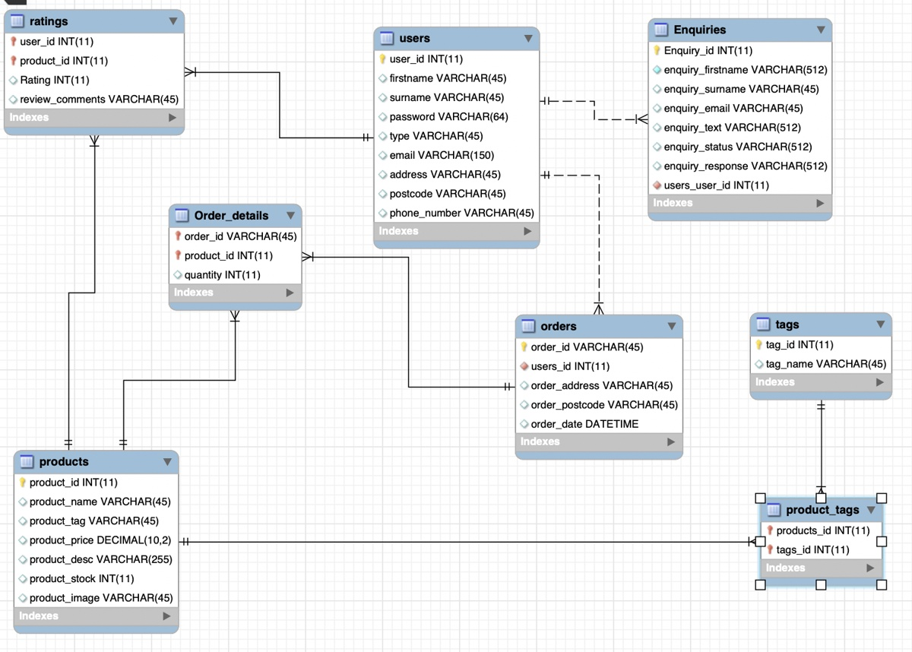

Users

Products

Tags

Orders

Enquiries

Ratings

Product_tags

Order_details

## User Interface Design

### Wireframes

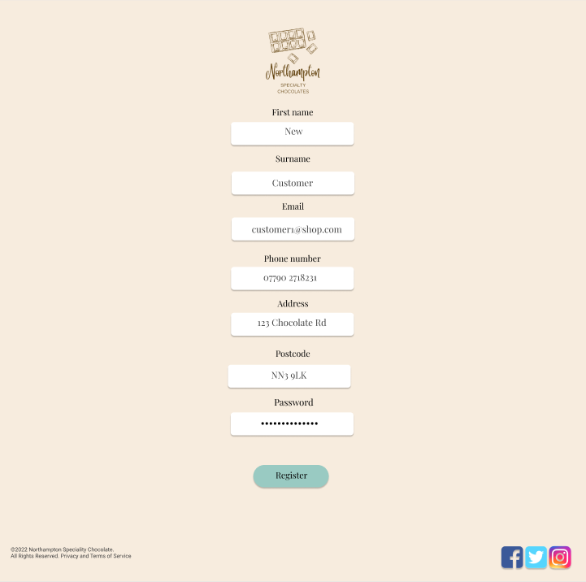

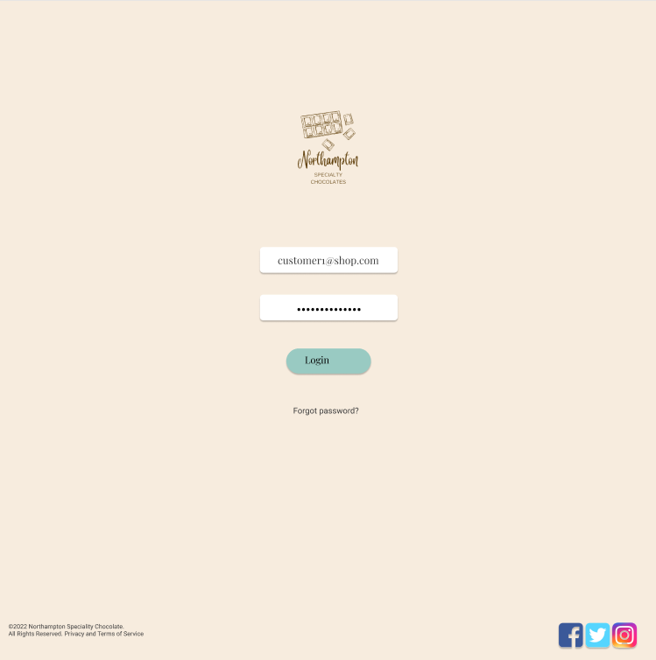

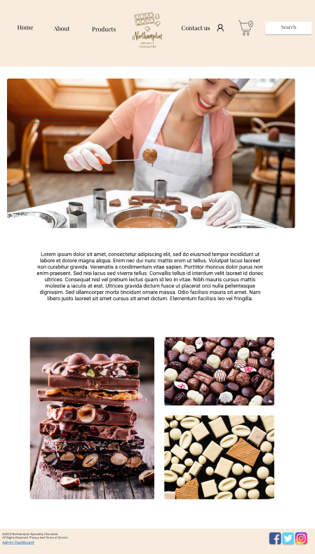

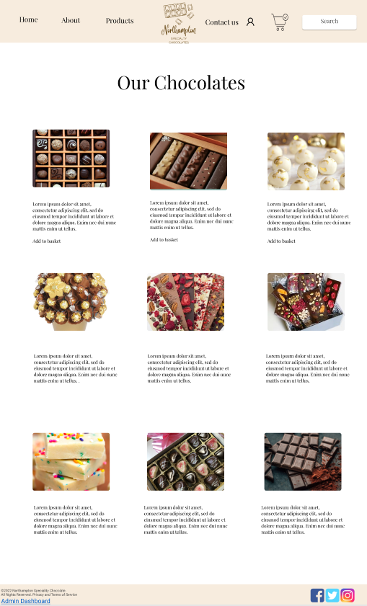

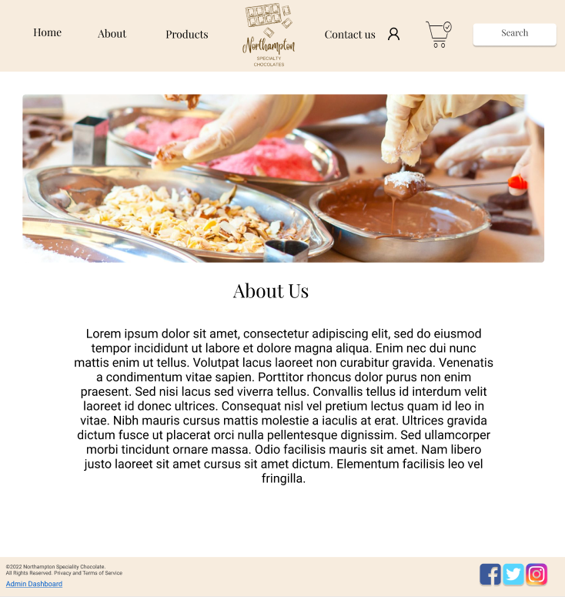

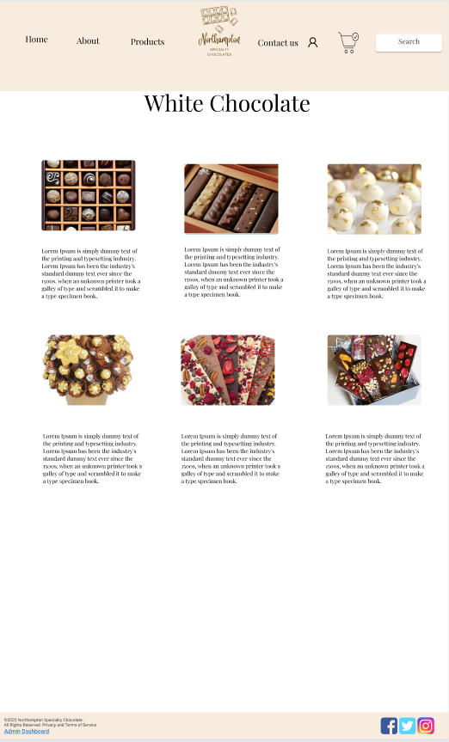

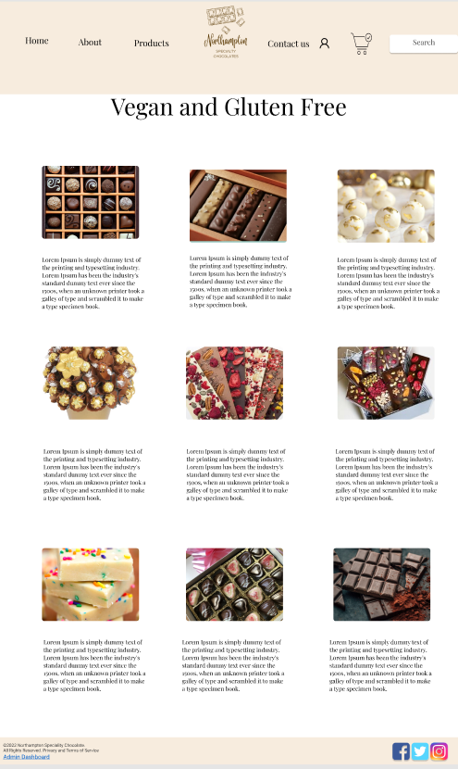

## System Integration Design

### Navigation Flowchart

This flowchart depicts the navigational structure of the online application. Each colour has a key, with green serving as the universal home page. The heading will be displayed in yellow on the navigation bar, and the drop-down choices will be displayed in orange. Once a person has logged in, the system will detect whether they are a customer or an administrator. Only an administrator will be able to see these websites, as shown by the red colour. The purple colour represents the lead/main admin, who has complete power over the web application.

### Class diagram

### Activity Diagram

The activity diagram shows how a customer can register on the web application. Firstly, the customer will click on the navigation bar where it will display the heading register. After the customer fills out the registration form, the web application runs a condition to see if all the text fields are valid. If the text fields are correct, the login page will appear; if they are incorrect, an error message will show, prompting the customer to re-enter the registration form.

This activity diagram shows the process of buying a product. Firstly, a customer will browse the products on the web application and add an item to the basket. Then, the web application will update the basket and display It to the user. It will then also ask the customer if they would like to continue shopping, if they press yes, they will be redirected to the products page, if no, it will check if the customer is logged in. If the customer is logged in, it will forward them to checkout, if they are not logged in, it will display a login page, where they can either log in or decide to continue as a guest. After that, they will also be sent to the checkout page. The user then has to enter their payment details and pick a payment method. After submitting this, the web application checks if all of the fields are filled out. If they are, the card details will be checked with the bank to confirm payment, if the fields are not filled out, the user is sent back to entering their payment details. After payment was submitted, and the bank has approved of the check, the invoice will be displayed. If the details entered are incorrect, the customer will be redirected back to entering their payment details until the payment goes through.

### Use Case diagram

### Sequence Diagram

This sequence diagram shows the process of a customer submitting a query. Submitting a query will create a database record and notify an admin for them to resolve it. Once the admin responds to it, the message from the administrator will be forwarded to the user. Then, the database record is updated with the message from the admin as well as the name of the admin that resolved it Diagram
This is a sequence diagram that explains how an administrator can edit a product. They must first log in, which will be validated by the web application by looking up the account's entry in the database. Only admins are authorised to edit products, hence a regular user account is unable to do so. After verification, the admin will be taken to the edit page, where they can change the title, price, or description. The database record will be updated after you submit this, and a confirmation message will appear on the screen.

This diagram also explains how you could edit a category, as both follow the same steps. For editing a category, you also need to be an administrator account, which will then allow you to change the categories title or add a new one.

This is a sequence diagram, displaying the way the web application operates when a customer buys a product. The customer will first be viewing the products, which will call a function to get the description of the product with its images from the database, and this will then be presented to the customer that is browsing the products page. The customer can then add one, or multiple items to the cart, which will call a function to calculate the total price. After that, the customer has to enter their payment details, which calls a function to verify the payment. When the payment goes through, an invoice is returned, which lets the customer see all of the order details.

# Prototype Implementation

## Build

**Programming language**

HTML, CSS, PHP, JavaScript

**Database**

MYSQL

**Software Architecture**

E-commerce system architecture two tier architecture will be used. The website will have a client-side and server-side with a constant interaction between client and server.

**Supporting tools**

Google docs for collaborative report writing

GitHub for collaborative coding and note sharing

Discord and emails for group communication

Figma for wireframes

Trello for group task allocation

## Software and Hardware

**Software:**

-          Visual Studio Code is the software we will be using to code the web pages, using PHP for the functionality of the web pages including password hashing and database handling. Additionally, HTML will be used for the structure of the web pages and CSS will be used to style them, JavaScript will be used for the auto mail response for the ticketing system using the node.js library.

-          Figma will be used to create the wire frames for each webpage, which will show the page layouts and basic functionality of these pages.

-          Bootstrap is the framework we have decided to use to simplify and speedup development.

-          MySQL is the database management system that will be used to build the database structure and hold the users and admin data. Including the usernames, passwords, previous sales, items in stock and cart items.

-          Live Server is a plugin for Visual Studio Code that simulates a web server allowing the team to test the site throughout development.

-          Docker will be used to run a webserver on our machines capable of running the PHP scripts.

**Hardware:**

Each member of Impact Development will be using a laptop with:

-          AMD Ryzen 3 3200U with on board graphics

-          8 GB of RAM

-          Windows 10 (64 Bit).

-          150 GB of Storage

## System User Guide

# Testing

## Unit Testing

White box testing to test internal functions of the code, testing specific units.

|  |  |  |  |  |  |
| --- | --- | --- | --- | --- | --- |
| Test Number | Condition | Input | Expected Output | Actual Output | Pass/Fail |
| 1 | $stmt = $pdo->prepare('DELETE FROM users WHERE user_id = :id');  $values=[      'id' => $_GET['id']  ];  $stmt->execute($values); | Admin deletes user id 2 | User id 2 deleted | User id 2 deleted | **Pass** |
| 2 | if(isset($_SESSION['loggedinadmin'])){  if(isset($_POST['submit'])){      $stmt = $pdo->prepare('UPDATE products SET product_name = :product_name, product_tag = :product_tag, product_price = :product_price, product_desc = :product_desc, product_stock = :product_stock, product_image = :product_image WHERE product_id= :product_id');        unset($_POST['submit']);      $stmt->execute($_POST);      header("Location: adminProducts.php");  } | Admin user adds product “Chocolate 2”, tag as “chocolate”, description as “chocolate bar”. Stock 2, image added | Product added “Chocolate 2”, tag as “chocolate”, description as “chocolate bar”. Stock 2, image uploaded to web application and product is assigned id in database | Product added “Chocolate 2”, tag as “chocolate”, description as “chocolate bar”. Stock 2, image uploaded to web application and product is assigned id in database | **Pass** |
| 2a |  | User not logged in as an admin | This option and user dashboard not displayed | This option and user dashboard not displayed | **Pass** |
| 3 | if(isset($_SESSION['products'])){   echo '<ul class="names">';  echo '<li><p>Thank you for your purchase of ' . $_SESSION['products'] .'</p></li>';  echo '<li><p>The total cost was £'  . $_SESSION['price'] .'</p></li>';  echo '<li><p>Your order is on the way!</p></li>';  echo '</ul>';  unset($_SESSION['products']);  unset($_SESSION['price']);  } | 2 gift box items in basket costing £5 when user presses “complete purchase button” | “Thank you for your purchase of 2 gift boxes  The total cost was £10” | “Thank you for your purchase of 2 gift box  The total cost was £10” | **Pass**  Wording slightly different than expected result due to multiple items, left as is as not a performance issue |
| 3a | else{      echo '<ul class="names">';  echo '<li><p>No items in basket</p></li>';  echo '</ul>';  } | User checks out with 0 items in basket | “No items in basket” displayed | “No items in basket” displayed | **Pass** |

## Integration Test

Black box testing to test the external behaviour of the system, testing the integration of the system as a whole.

|  |  |  |  |
| --- | --- | --- | --- |
| **Test** | **Expected Output** | **Actual Output** | **Pass/Fail** |
| Create an account. | Users’ details should be saved to the database. | Users’ information is saved to the database and successfully registers the user. | **Pass** |
| Login to account. | User should be able to login with email and password that they used to create the account. | There was a slight problem at first where the login was not working but that has been fixed and now allows the user to login. | **Pass** |
| View all web pages using navigation bar. | All web pages should be able to be viewed without any broken pages. | All pages on the navigation can be easily accessed and allowed all user to navigate too. | **Pass** |
| Search bar. | An item can be searched and should take the user to that item. | When trying to search product, nothing comes up. | **Fail**  Development team have decided to implement this in future improvements agreed with the client |
| Add to shopping cart. | Once an item is selected there should be a button to add that item to the shopping cart. |  |  |
| Delete from shopping cart. | An item should be able to be deleted once saved in the shopping cart. |  |  |
| Update quantity in shopping cart. | More than one item should be able to have more added to it. |  |  |
| Shopping cart to calculate amount paid. | The shopping cart should show the total amount if there is more than one added. |  |  |
| Enter in contact form. | User should be able to fill out the contact form and the form should send an enquiry to the admin. | Once information was entered into the contact form, the information is sent to the admin enquiry page. | Pass |
| Tweets should be loaded on contact page. | User should be able to view tweets on the contact page from the business. | The tweets loaded once the contact page has been visited. | Pass |
| Admin login. | Once an admin login’s, a link should appear for them to view the admin dashboard of the website. | An admin can login and see the admin dashboard for the website | Pass |
| Admin add products. | An admin should be able to add new products to the website. |  |  |
| Admin delete products. | An admin should be able to delete products from the website. |  |  |
| Admin update products. | An admin should be able to edit and update a product. |  |  |
| Admin view accounts. | An admin should be able to see a list of all the accounts that have been created. | The admin can see the list of accounts that have registered. | Pass |
| Admin remove accounts. | An admin should be able to remove user accounts. | The admin can remove accounts and users. | Pass |
| Admin view enquires. | An admin should be able to see a list of enquires that have been submitted. | The admin can see the enquires that came through. | Pass |
| Master admin login. | One main admin account should be able to view the master admin dashboard. |  |  |
| Master admins add an admin account. | The master admin should be able to add a user to be an admin. |  |  |
| Master admins remove admin account. | The master admin should be able to remove any admin account. | The admin can remove other admins. | Pass |

## End of Production Customer Evaluation

### Customer Questionnaire

Test access was given to 15 customers who completed purchases, after using the website they were emailed a short questionnaire for feedback. The results were converted to percentages. The result will help Impact Development to look for future improvements for the web application for customer experience.

|  |  |  |  |  |
| --- | --- | --- | --- | --- |
| **Question** | **Strongly disagree** | **Disagree** | **Agree** | **Strongly Agree** |
|  |  |  |  |  |
|  |  |  |  |  |
|  |  |  |  |  |
|  |  |  |  |  |
|  |  |  |  |  |
|  |  |  |  |  |
|  |  |  |  |  |
|  |  |  |  |  |
|  |  |  |  |  |
|  |  |  |  |  |
|  |  |  |  |  |
|  |  |  |  |  |
|  |  |  |  |  |
|
|  |  |  |  |  |
|  |  |  |  |  |
|  |  |  |  |  |
|  |  |  |  |  |
| Additional comments: |  | | | |

### Client Interview

The prototype was given to the client for feedback on admin features. To look for bugs and potential improvement, the client and owner of Northampton Speciality Chocolates was emailed a interview after using the system.

|  |  |
| --- | --- |
| Question | Answer |
|  |  |
|  |  |
|  |  |
|  |  |
|  |  |
|  |  |
|  |  |

# Conclusion

## Strengths and Weaknesses

## Future works

# References

# Appendix of Source code

## navbar.php

<nav>

<a href="index.php"><img src="/images/Logo.png" alt="Logo" class="logo"/></a>

<ul>

<li><a href="index.php">Home</a></li>

<li><a href="about.php">About</a></li>

<li><a href="products.php">Products</a></li>

<li><a href="contact.php">Contact Us</a></li>

<?php if(isset($_SESSION['loggedinadmin'])) {?>

<li><a href="admin.php">Admin</a></li>

<?php }

if(isset($_SESSION['loggedin']) || isset($_SESSION['loggedinadmin'])){ ?>

<li><a href="logout.php">Logout</a></li>

<?php

}

?>

<li><a href="login.php"><img src ="/images/usericon.png" alt="User" class="usericon"></a></li>

<li><a href="cart.php"><img src ="/images/shoppingcart.png" alt="Shopping Cart" class="shoppingcart"></a></li>

<input type="text" placeholder="Search">

</ul>

</nav>

## footer.php

<footer>©2022 Northampton Speciality Chocolate.

All Rights Reserved. Privacy and Terms of Service</footer>

## about.php

<!DOCTYPE html>

<html lang="en" >

<head>

<meta charset="UTF-8">

<title>Northampton Chocolates</title>

<link rel="stylesheet" href="./style.css">

</head>

<body>

<!-- partial:index.partial.html -->

<div class="container">

<?php

require 'templates/navbar.php';

?>

<main>

<div class="container"> </div>

<p> Northampton Speciality Chocloates is a family founded, luxury, handmade chocolate supplier and chocolatier. Based in Northampton, our chocolatiers work to provide a variety of sweet treats for your every need! We are a brand new buisness that makes and

supplies a range of different chocolates, organically sourced with gluten free and vegan options. We would be happy to suit your personal requests, special gift ideas, personalisation and dietary requirements using our contact us page. Buy chocolate gifts,

chocolate hampers, gift boxes aSnd personalised gifts for someone special.. or induldge yourself. Chocolate delivery direct to your door.

</p>

<h2>other section</h2>

<p>Lorem ipsum dolor sit amet consectetur, adipisicing elit. Quasi aspernatur maiores rem velit totam praesentium iure, neque autem explicabo fuga odio. Tempora harum reiciendis totam tenetur reprehenderit tempore debitis laudantium!

Et quibusdam natus aperiam, nam sed illum quae vel libero rerum aut provident architecto repellendus ipsum possimus. Iure, sequi maxime. Beatae id libero unde culpa necessitatibus eaque blanditiis laudantium voluptate.

Enim laudantium autem atque sint dicta ullam, quod, dolorum architecto dolores harum quaerat vero, obcaecati vitae consequuntur laboriosam nostrum non pariatur asperiores reprehenderit voluptatum veritatis aliquam iusto expedita! Blanditiis, laboriosam!

Recusandae, reiciendis eveniet, amet rerum perspiciatis est tenetur, numquam officia consequatur aperiam dolor quasi sunt repudiandae repellat! Perferendis magni, asperiores esse expedita, deserunt maiores illo, fugiat voluptates ipsum rerum quis?

Reiciendis excepturi, iste cupiditate necessitatibus et quos ipsa nesciunt quia doloribus quas molestiae, quisquam voluptas cum totam sequi error labore, ducimus eligendi eius nostrum in non laborum! Est, consequatur tempora!

Amet voluptatem, repudiandae, numquam maxime beatae inventore voluptas aspernatur, recusandae natus perspiciatis aperiam. Exercitationem repellendus delectus tempora quo rerum, iure labore debitis, dolores aut inventore, hic blanditiis aliquid fugit sint.</p>

<p>Lorem ipsum dolor sit amet consectetur, adipisicing elit. Quasi aspernatur maiores rem velit totam praesentium iure, neque autem explicabo fuga odio. Tempora harum reiciendis totam tenetur reprehenderit tempore debitis laudantium!

Et quibusdam natus aperiam, nam sed illum quae vel libero rerum aut provident architecto repellendus ipsum possimus. Iure, sequi maxime. Beatae id libero unde culpa necessitatibus eaque blanditiis laudantium voluptate.

Enim laudantium autem atque sint dicta ullam, quod, dolorum architecto dolores harum quaerat vero, obcaecati vitae consequuntur laboriosam nostrum non pariatur asperiores reprehenderit voluptatum veritatis aliquam iusto expedita! Blanditiis, laboriosam!

Recusandae, reiciendis eveniet, amet rerum perspiciatis est tenetur, numquam officia consequatur aperiam dolor quasi sunt repudiandae repellat! Perferendis magni, asperiores esse expedita, deserunt maiores illo, fugiat voluptates ipsum rerum quis?

Reiciendis excepturi, iste cupiditate necessitatibus et quos ipsa nesciunt quia doloribus quas molestiae, quisquam voluptas cum totam sequi error labore, ducimus eligendi eius nostrum in non laborum! Est, consequatur tempora!

Amet voluptatem, repudiandae, numquam maxime beatae inventore voluptas aspernatur, recusandae natus perspiciatis aperiam. Exercitationem repellendus delectus tempora quo rerum, iure labore debitis, dolores aut inventore, hic blanditiis aliquid fugit sint.</p>

<p>Lorem ipsum dolor sit amet consectetur, adipisicing elit. Quasi aspernatur maiores rem velit totam praesentium iure, neque autem explicabo fuga odio. Tempora harum reiciendis totam tenetur reprehenderit tempore debitis laudantium!

Et quibusdam natus aperiam, nam sed illum quae vel libero rerum aut provident architecto repellendus ipsum possimus. Iure, sequi maxime. Beatae id libero unde culpa necessitatibus eaque blanditiis laudantium voluptate.

Enim laudantium autem atque sint dicta ullam, quod, dolorum architecto dolores harum quaerat vero, obcaecati vitae consequuntur laboriosam nostrum non pariatur asperiores reprehenderit voluptatum veritatis aliquam iusto expedita! Blanditiis, laboriosam!

Recusandae, reiciendis eveniet, amet rerum perspiciatis est tenetur, numquam officia consequatur aperiam dolor quasi sunt repudiandae repellat! Perferendis magni, asperiores esse expedita, deserunt maiores illo, fugiat voluptates ipsum rerum quis?

Reiciendis excepturi, iste cupiditate necessitatibus et quos ipsa nesciunt quia doloribus quas molestiae, quisquam voluptas cum totam sequi error labore, ducimus eligendi eius nostrum in non laborum! Est, consequatur tempora!

Amet voluptatem, repudiandae, numquam maxime beatae inventore voluptas aspernatur, recusandae natus perspiciatis aperiam. Exercitationem repellendus delectus tempora quo rerum, iure labore debitis, dolores aut inventore, hic blanditiis aliquid fugit sint.</p>

</main>

<?php

require 'templates/footer.php'

?>

## addAdmin.php

<?php

ob_start();

session_start();

require 'database.php';

?>

<!DOCTYPE html>

<html lang="en">

<head>

<meta charset="UTF-8">

<meta http-equiv="X-UA-Compatible" content="IE=edge">

<meta name="viewport" content="width=device-width, initial-scale=1.0">

<link rel="stylesheet" href="./style.css">

<title>Add Admin</title>

</head>

<body>

<?php

require 'templates/navbar.php';

if(isset($_SESSION['loggedinadmin'])){

if(isset($_POST['submit'])){

$stmt = $pdo -> prepare('INSERT INTO users(firstname, surname, password, type, email, address, postcode, phone_number) VALUES (:firstname, :surname, :password, :type, :email, :address, :postcode, :phone_number)');

$valid = true;

$nonempty = ['firstname', 'surname', 'email', 'password', 'address', 'postcode', 'phone_number'];

foreach ($nonempty as $field) {

if ($_POST[$field] == '') {

$valid = false;

echo '<p>You must enter your ' . $field . '</p>'; //ensure each field is filled out

}

}

if ($valid == true){

$input = [

'firstname' => $_POST['firstname'],

'surname' => $_POST['surname'],

'password' => $_POST['password'],

'type' => 'admin',

'email' => $_POST['email'],

'address' => $_POST['address'],

'postcode' => $_POST['postcode'],

'phone_number' => $_POST['phone_number']

];

$stmt->execute($input);

header("Location: admins.php");

}

else{

}

}

else{

?>

<main>

<div class='bold-line'></div>

<div class='wrapper'>

<div class='windowsignup'>

<div class='overlaysignup'></div>

<div class='content'>

<div class='input-fields'>

<form action= "addAdmin.php" method= "POST">

<input type='text' placeholder='Firstname' class='input-line full-width' name="firstname"/>

<input type='text' placeholder='Surname' class='input-line full-width' name="surname"/>

<input type='text' placeholder='Email' class='input-line full-width' name="email"/>

<input type='password' placeholder='Password' class='input-line full-width' name="password"/>

<input type='text' placeholder='Address' class='input-line full-width' name="address"/>

<input type='text' placeholder='Postcode' class='input-line full-width' name="postcode"/>

<input type='text' placeholder='Phone number' class='input-line full-width' name="phone_number"/>

</div>

<div><input type="submit" class='ghost-round full-width' name="submit" value="Submit" /></div>

</div>

</div>

</div>

</form>

<?php

}

}

else{

echo '<main class="basketbody">';

echo '<p class="names"> Only admins can view this page</p>';

}

?>

</main>

<?php

require 'templates/footer.php';

?>

</body>

</html>

## addProduct.php

<?php

ob_start();

session_start();

require 'database.php';

?>

<!DOCTYPE html>

<html lang="en">

<head>

<meta charset="UTF-8">

<meta http-equiv="X-UA-Compatible" content="IE=edge">

<meta name="viewport" content="width=device-width, initial-scale=1.0">

<link rel="stylesheet" href="./style.css">

<title>Add Product</title>

</head>

<body>

<?php

require 'templates/navbar.php';

if(isset($_SESSION['loggedinadmin'])){

if(isset($_POST['submit'])){

$filename = $_FILES["uploadfile"]["name"];

$tempname = $_FILES["uploadfile"]["tmp_name"];

$folder = "images/".$filename;

if (move_uploaded_file($tempname, $folder)) {

$msg = "Image uploaded successfully";

}else{

$msg = "Failed to upload image";

}

$stmt = $pdo -> prepare('INSERT INTO products (product_name, product_tag, product_price, product_desc, product_stock, product_image) VALUES (:product_name, :product_tag, :product_price, :product_desc, :product_stock, :product_image)');

$valid = true;

$nonempty = ['product_name', 'product_tag', 'product_price', 'product_desc', 'product_desc', 'product_stock', 'product_image'];

foreach ($nonempty as $field) {

if ($_POST[$field] == '') {

$valid = false;

echo '<p>You must enter your ' . $field . '</p>'; //ensure each field is filled out

}

}

if ($valid == true){

$input = [

'product_name' => $_POST['product_name'],

'product_tag' => $_POST['product_tag'],

'product_price' => $_POST['product_price'],

'product_desc' => $_POST['product_desc'],

'product_stock' => $_POST['product_stock'],

'product_image' => $_POST['product_image']

];

$stmt->execute($input);

header("Location: adminProducts.php");

}

else{

}

}

else{

?>

<main>

<div class='bold-line'></div>

<div class='wrapper'>

<div class='windowproduct'>

<div class='overlayproduct'></div>

<div class='content'>

<div class='input-fields'>

<form enctype="multipart/form-data" action= "addProduct.php" method= "POST">

<input type='text' placeholder='Product Name' class='input-line full-width' name="product_name"/>

<input type='text' placeholder='Product Tag' class='input-line full-width' name="product_tag"/>

<input type='text' placeholder='Price' class='input-line full-width' name="product_price"/>

<input type='text' placeholder='Description' class='input-line full-width' name="product_desc"/>

<input type='text' placeholder='Stock' class='input-line full-width' name="product_stock"/>

<input type='text' placeholder='Image Name' class='input-line full-width' name="product_image"/>

<input type="file" name="uploadfile"></input>

</div>

<div><input type="submit" class='ghost-round full-width' name="submit" value="Submit" /></div>

</div>

</div>

</div>

</form>

<?php

}

}

else{

echo '<main class="basketbody">';

echo '<p class="names"> Only admins can view this page</p>';

}

?>

</main>

<?php

require 'templates/footer.php';

?>

</body>

</html>

## addToBasket.php

<?php

require 'database.php';

session_start();

?>

<!DOCTYPE html>

<html lang="en">

<head>

<meta charset="UTF-8">

<meta http-equiv="X-UA-Compatible" content="IE=edge">

<meta name="viewport" content="width=device-width, initial-scale=1.0">

<link rel="stylesheet" href="./style.css">

<title>Add to basket</title>

</head>

<body>

<?php

require 'templates/navbar.php';

$stmt = $pdo->prepare('SELECT * FROM products WHERE product_id = :product_id');

$values = [

'product_id' => $_GET['id']

];

$stmt->execute($values);

$products = $stmt->fetch();

?>

<main class="basketbody">

<h1 id="manageusers">Basket</h1>

<?php

if(!isset($_SESSION['products'])){

$_SESSION['products'] = $products['product_name'];

$_SESSION['price'] = $products['product_price'];

}

else{

}

$_SESSION['products'] = $_SESSION['products'] . ', ' . ' ' . $products['product_name'];

$_SESSION['price'] = $_SESSION['price'] + $products['product_price'];

echo '<p class="names">Item ' . $products['product_name'] . ' added to basket.</p>';

?>

</main>

<?php

require 'templates/footer.php';

?>

</body>

</html>

## admin.php

<?php

session_start();

require 'database.php';

?>

<!DOCTYPE html>

<html lang="en">

<head>

<meta charset="UTF-8">

<meta http-equiv="X-UA-Compatible" content="IE=edge">

<meta name="viewport" content="width=device-width, initial-scale=1.0">

<link rel="stylesheet" href="style.css"/>

<title>Admin</title>

</head>

<body>

<?php if(isset($_SESSION['loggedinadmin'])){

?>

<?php require 'templates/navbar.php' ?>

<main class="basketbody2">

<h1 id="manageusers">Admin Dashboard</h1>

<div class="button">

<a href="users.php">Manage Users</a>

</div>

<?php

if(isset($_SESSION['loggedinmaster'])){

echo '<div class="button">

<a href="admins.php">Manage Admins</a>

</div>';

}

?>

<div class="button">

<a href="enquiries.php">Enquiries</a>

</div>

<div class="button">

<a href="resolvedEnquiries.php">Resolved Enquiries</a>

</div>

<div class="button">

<a href="adminProducts.php">Products</a>

</div>

<?php

}

else{

echo '<main class="basketbody">';

echo '<p class="names"> Only admins can view this page</p>';

}

?>

</main>

</body>

<?php

require 'templates/footer.php';

?>

</html>

## adminProducts.php

<?php

session_start();

require 'database.php';

?>

<!DOCTYPE html>

<html lang="en">

<head>

<meta charset="UTF-8">

<meta http-equiv="X-UA-Compatible" content="IE=edge">

<meta name="viewport" content="width=device-width, initial-scale=1.0">

<link rel="stylesheet" href="style.css"/>

<title>Products</title>

</head>

<body>

<?php

require 'templates/navbar.php';

if(isset($_SESSION['loggedinadmin'])){

$stmt = $pdo -> prepare('SELECT * FROM products');

$stmt -> execute();

$products = $stmt->fetchAll();

?>

<main>

<h1 id="manageusers">Manage Products</h1>

<ul class="names">

<?php

foreach($products as $product )

{

echo '<li>Item code: ' . $product['product_id'] . '</li>';

echo '<li>Product name: ' . $product['product_name'] . '</li>';

echo '<li>Product Tag: ' . $product['product_tag'] . '</li>';

echo '<li>Product Price: £' . $product['product_price'] . '</li>';

echo '<li>Product Stock: ' . $product['product_stock'] . '</li>';

echo '<li>Product Image Name: ' . $product['product_image'] . '</li>';

echo '<li><a class = "button2" href="editProduct.php?id=' . $product['product_id'] . '">Edit Product</a>';

echo '<a class = "button2" href="deleteProduct.php?id=' . $product['product_id'] . '">Delete Product</a>';

echo '</li>';

}

?>

<div class ="button"><a href="addProduct.php">Add Product</a></div>

</ul>

<?php

}

else{

echo '<main class="basketbody">';

echo '<p class="names"> Only admins can view this page</p>';

}

?>

</main>

<?php

require 'templates/footer.php';

?>

</body>

</html>

## admins.php

<?php

session_start();

require 'database.php';

?>

<!DOCTYPE html>

<html lang="en">

<head>

<meta charset="UTF-8">

<meta http-equiv="X-UA-Compatible" content="IE=edge">

<meta name="viewport" content="width=device-width, initial-scale=1.0">

<link rel="stylesheet" href="style.css"/>

<title>Admins</title>

</head>

<body>

<?php

if(isset($_SESSION['loggedinmaster'])){

require 'templates/navbar.php';

$stmt = $pdo -> prepare('SELECT * FROM users WHERE type = :type');

$values = [

'type' => 'admin'

];

$stmt -> execute($values);

$user = $stmt->fetchAll();

?>

<main class="basketbody2">

<h1 id="manageusers">Manage Admins</h1>

<ul class="names">

<?php

foreach($user as $user )

{

echo '<li>Name: ' . $user['firstname']. ' ' . $user['surname'] ;

echo ' <a class = "button2"href="editAdmin.php?id=' . $user['user_id'] . '">Edit</a>';

echo '<a class = "button2" href="deleteAdmin.php?id=' . $user['user_id'] . '">Delete</a>';

echo '</li> ';

}

?>

<div class ="button"><a href="addAdmin.php">Add Admin</a></div>

</ul>

<?php

}

else{

echo '<main class="basketbody">';

echo '<p class="names"> Only admins can view this page</p>';

}

?>

</main>

<?php

require 'templates/footer.php';

?>

</body>

</html>

## buy.php

<?php

session_start();

require 'database.php';

?>

<!DOCTYPE html>

<html lang="en">

<head>

<meta charset="UTF-8">

<meta http-equiv="X-UA-Compatible" content="IE=edge">

<meta name="viewport" content="width=device-width, initial-scale=1.0">

<link rel="stylesheet" href="style.css"/>

<title>Buy</title>

</head>

<body>

<?php

require 'templates/navbar.php';

?>

<main class="basketbody">

<h1 id="manageusers">Basket</h1>

<?php

if(isset($_SESSION['products'])){

echo '<ul class="names">';

echo '<li><p>Items: ' . $_SESSION['products'] . '</p></li>';

echo '<li><p>Price: £' . $_SESSION['price'] . '</p></li>';

echo '<div class="button">

<a href="paypal.php">PayPal</a>

</div>';

echo '<div class="button">

<a href="payment.php">Credit/DebitCard</a>

</div>';

echo '</ul>';

}

else{

echo '<ul class="names">';

echo '<li><p>No items in basket</p></li>';

echo '</ul>';

}

?>

</main>

<?php

require 'templates/footer.php';

?>

</body>

</html>

## cart.php

<?php

session_start();

require 'database.php';

?>

<!DOCTYPE html>

<html lang="en">

<head>

<meta charset="UTF-8">

<meta http-equiv="X-UA-Compatible" content="IE=edge">

<meta name="viewport" content="width=device-width, initial-scale=1.0">

<link rel="stylesheet" href="style.css"/>

<title>Basket</title>

</head>

<body>

<?php

require 'templates/navbar.php';

?>

<main class="basketbody">

<h1 id="manageusers">Basket</h1>

<?php

if(isset($_SESSION['products'])){

echo '<ul class="names">';

echo '<li><p>Items: ' . $_SESSION['products'] . '</p></li>';

echo '<li><p>Price: £' . $_SESSION['price'] . '</p></li>';

echo '<div class="button">

<a href="clearCart.php">Clear</a>

</div>';

echo '<div class="button">

<a href="buy.php">Buy</a>

</div>';

echo '</ul>';

}

else{

echo '<ul class="names">';

echo '<li><p>No items in basket</p></li>';

echo '</ul>';

}

?>

</main>

<?php

require 'templates/footer.php';

?>

</body>

</html>

## clearCart.php

<?php

ob_start();

session_start();

unset($_SESSION['products']);

unset($_SESSION['price']);

?>

<!DOCTYPE html>

<html lang="en">

<head>

<meta charset="UTF-8">

<meta http-equiv="X-UA-Compatible" content="IE=edge">

<meta name="viewport" content="width=device-width, initial-scale=1.0">

<link rel="stylesheet" href="./style.css">

<title>Logout</title>

</head>

<body>

<?php

require 'templates/navbar.php';

header("Location: cart.php");

?>

<main>

</main>

<?php

require 'templates/footer.php';

?>

</body>

</html>

## contact.php

<?php

session_start();

require 'database.php';

?>

<!DOCTYPE html>

<html lang="en" >

<head>

<meta charset="UTF-8">

<title>Northampton Chocolates</title>

<link rel="stylesheet" href="./style.css">

</head>

<body>

<div class="container">

<?php

require 'templates/navbar.php';

?>

<main>

<?php

if(isset($_POST['submit'])){

$stmt = $pdo -> prepare('INSERT INTO Enquiries(enquiry_firstname, enquiry_surname, enquiry_email, enquiry_text, enquiry_status, enquiry_response) VALUES (:enquiry_firstname, :enquiry_surname, :enquiry_email, :enquiry_text, :enquiry_status, :enquiry_response)');

$input = [

'enquiry_firstname' => $_POST['enquiry_firstname'],

'enquiry_surname' => $_POST['enquiry_surname'],

'enquiry_email' => $_POST['enquiry_email'],

'enquiry_text' => $_POST['enquiry_text'],

'enquiry_status' => 'Unresolved',

'enquiry_response' => 'None'

];

$stmt->execute($input);

}

else{

?>

<h1>Contact Us</h1>

<form action= "contact.php" method= "POST">

<input type='text' placeholder='First name' class='input-line full-width' name="enquiry_firstname"/>

<input type='text' placeholder='Surname' class='input-line full-width' name="enquiry_surname"/>

<input type='text' placeholder='Email' class='input-line full-width' name="enquiry_email"/>

<textarea placeholder='Message' name='enquiry_text' class='input-line full-width'></textarea>

<input type="submit" class='ghost-round full-width' name="submit" value="Submit" />

</form>

<?php

}

?>

<h1>Social Media</h1>

<div class=links>

<ul>

<li><a href="https://twitter.com/SpecialityChocs">Twitter</a>

</li>

<li><a href="https://facebook.com">Facebook</a>

</li>

<li><a href="https://www.instagram.com/">Instagram</a>

</ul>

</div>

<a class="twitter-timeline" href="https://twitter.com/SpecialityChocs?ref_src=twsrc%5Etfw">Tweets by SpecialityChocs</a>

<script async src="https://platform.twitter.com/widgets.js" charset="utf-8"></script>

</main>

<?php

require 'templates/footer.php';

?>

</div>

</body>

</html>

## database.php

<?php

$server = 'mysql';

$username = 'student';

$password = 'student';

$schema = 'mydb';

$pdo = new PDO('mysql:dbname=' . $schema . ';host=' . $server, $username, $password);

## deleteAdmin.php

<?php

ob_start();

session_start();

require 'database.php';

?>

<!DOCTYPE html>

<html lang="en">

<head>

<meta charset="UTF-8">

<meta http-equiv="X-UA-Compatible" content="IE=edge">

<meta name="viewport" content="width=device-width, initial-scale=1.0">

<link rel="stylesheet" href="./style.css">

<title>Delete</title>

</head>

<body>

<main>

<?php

require 'templates/navbar.php';

if(isset($_SESSION['loggedinadmin'])){

$stmt = $pdo->prepare('DELETE FROM users WHERE user_id = :id');

$values=[

'id' => $_GET['id']

];

$stmt->execute($values);

header("Location: admins.php");

}

else{

echo '<main class="basketbody">';

echo '<p class="names"> Only admins can view this page</p>';

}

?>

<?php

require 'templates/footer.php';

?>

</main>

</body>

</html>

## deleteProduct.php

<?php

ob_start();

session_start();

require 'database.php';

?>

<!DOCTYPE html>

<html lang="en">

<head>

<meta charset="UTF-8">

<meta http-equiv="X-UA-Compatible" content="IE=edge">

<meta name="viewport" content="width=device-width, initial-scale=1.0">

<link rel="stylesheet" href="./style.css">

<title>Delete</title>

</head>

<body>

<main>

<?php

require 'templates/navbar.php';

if(isset($_SESSION['loggedinadmin'])){

$stmt = $pdo->prepare('DELETE FROM products WHERE product_id = :id');

$values=[

'id' => $_GET['id']

];

$stmt->execute($values);

header("Location: adminProducts.php");

?>

<?php

}

else{

echo '<main class="basketbody">';

echo '<p class="names"> Only admins can view this page</p>';

}

require 'templates/footer.php';

?>

</main>

</body>

</html>

## deleteUser.php

<?php

ob_start();

session_start();

require 'database.php';

?>

<!DOCTYPE html>

<html lang="en">

<head>

<meta charset="UTF-8">

<meta http-equiv="X-UA-Compatible" content="IE=edge">

<meta name="viewport" content="width=device-width, initial-scale=1.0">

<link rel="stylesheet" href="./style.css">

<title>Delete</title>

</head>

<body>

<main>

<?php

require 'templates/navbar.php';

if(isset($_SESSION['loggedinadmin'])){

$stmt = $pdo->prepare('DELETE FROM users WHERE user_id = :id');

$values=[

'id' => $_GET['id']

];

$stmt->execute($values);

header("Location: users.php");

}

else{

echo '<main class="basketbody">';

echo '<p class="names"> Only admins can view this page</p>';

}

?>

<?php

require 'templates/footer.php';

?>

</main>

</body>

</html>

## editAdmin.php

<?php

ob_start();

session_start();

require 'database.php';

?>

<!DOCTYPE html>

<html lang="en">

<head>

<meta charset="UTF-8">

<meta http-equiv="X-UA-Compatible" content="IE=edge">

<meta name="viewport" content="width=device-width, initial-scale=1.0">

<link rel="stylesheet" href="./style.css">

<title>Edit User</title>

</head>

<body>

<?php

require 'templates/navbar.php';

if(isset($_SESSION['loggedinadmin'])){

if(isset($_POST['submit'])){

$stmt = $pdo->prepare('UPDATE users SET firstname = :firstname, surname = :surname, email = :email, password = :password, address = :address, postcode = :postcode, phone_number = :phone_number WHERE user_id= :user_id');

unset($_POST['submit']);

$stmt->execute($_POST);

header("Location: admins.php");

}

else{

$stmt = $pdo->prepare('SELECT * FROM users WHERE user_id = :id');

$values = [

'id' => $_GET['id']

];

$stmt->execute($values);

$user = $stmt->fetch();

?>

<main>

<form action="<?php $_GET['id'] ?>" method="POST">

<div class='bold-line'></div>

<div class='wrapper'>

<div class='windowedit2'>

<div class='overlayedit2'></div>

<div class='content'>

<div class='input-fields'>

<form action= "editAdmin.php" method= "POST">

<label>Firstname:</label><input type='text' placeholder='Firstname' class='input-line full-width' name="firstname" value="<?php echo $user['firstname']; ?>"/>

<label>Surname:</label><input type='text' placeholder='Surname' class='input-line full-width' name="surname" value="<?php echo $user['surname']; ?>"/>

<label>Email:</label><input type='text' placeholder='Email' class='input-line full-width' name="email" value="<?php echo $user['email']; ?>"/>

<label>Password:</label><input type='text' placeholder='Password' class='input-line full-width' name="password" value="<?php echo $user['password']; ?>"/>

<label>Address:</label><input type='text' placeholder='Address' class='input-line full-width' name="address" value="<?php echo $user['address']; ?>"/>

<label>Postcode:</label><input type='text' placeholder='Postcode' class='input-line full-width' name="postcode" value="<?php echo $user['postcode']; ?>"/>

<label>Phone number:</label><input type='text' placeholder='Phone number' class='input-line full-width' name="phone_number" value="<?php echo $user['phone_number']; ?>"/>

<input type="hidden" name="user_id" value="<?php echo $user['user_id']; ?>"/>

</div>

<div><input type="submit" class='ghost-round full-width' name="submit" value="Submit" /></div>

</div>

</div>

</div>

</form>

<?php

}

}

else{

echo '<main class="basketbody">';

echo '<p class="names"> Only admins can view this page</p>';

}

?>

</main>

<?php

require 'templates/footer.php';

?>

</body>

</html>

## editProduct.php

<?php

ob_start();

session_start();

require 'database.php';

?>

<!DOCTYPE html>

<html lang="en">

<head>

<meta charset="UTF-8">

<meta http-equiv="X-UA-Compatible" content="IE=edge">

<meta name="viewport" content="width=device-width, initial-scale=1.0">

<link rel="stylesheet" href="./style.css">

<title>Edit Product</title>

</head>

<body>

<?php

require 'templates/navbar.php';

if(isset($_SESSION['loggedinadmin'])){

if(isset($_POST['submit'])){

$stmt = $pdo->prepare('UPDATE products SET product_name = :product_name, product_tag = :product_tag, product_price = :product_price, product_desc = :product_desc, product_stock = :product_stock, product_image = :product_image WHERE product_id= :product_id');

unset($_POST['submit']);

$stmt->execute($_POST);

header("Location: adminProducts.php");

}

else{

$stmt = $pdo->prepare('SELECT * FROM products WHERE product_id = :id');

$values = [

'id' => $_GET['id']

];

$stmt->execute($values);

$product = $stmt->fetch();

?>

<main>

<form action="<?php $_GET['id'] ?>" method="POST">

<div class='bold-line'></div>

<div class='wrapper'>

<div class='windowedit'>

<div class='overlayedit'></div>

<div class='content'>

<div class='input-fields'>

<form action= "editProduct.php" method= "POST">

<label>Product Name:</label> <input type='text' placeholder='Product Name' class='input-line full-width' name="product_name" value="<?php echo $product['product_name']; ?>"/>

<label>Product Tag:</label> <input type='text' placeholder='Product Tag' class='input-line full-width' name="product_tag" value="<?php echo $product['product_tag']; ?>"/>

<label>Price:</label> <input type='text' placeholder='Price' class='input-line full-width' name="product_price" value="<?php echo $product['product_price']; ?>"/>

<label>Description:</label> <input type='text' placeholder='Description' class='input-line full-width' name="product_desc" value="<?php echo $product['product_desc']; ?>"/>

<label>Stock:</label> <input type='text' placeholder='Stock' class='input-line full-width' name="product_stock" value="<?php echo $product['product_stock']; ?>"/>

<label>Image Name:</label> <input type='text' placeholder='Image Name' class='input-line full-width' name="product_image" value="<?php echo $product['product_image']; ?>"/>

<input type="hidden" name="product_id" value="<?php echo $product['product_id']; ?>"/>

</div>

<div><input type="submit" class='ghost-round full-width' name="submit" value="Submit" /></div>

</div>

</div>

</div>

</form>

<?php

}

}

else{

echo '<main class="basketbody">';

echo '<p class="names"> Only admins can view this page</p>';

}

?>

</main>

<?php

require 'templates/footer.php';

?>

</body>

</html>

## editUser.php

<?php

ob_start();

session_start();

require 'database.php';

?>

<!DOCTYPE html>

<html lang="en">

<head>

<meta charset="UTF-8">

<meta http-equiv="X-UA-Compatible" content="IE=edge">

<meta name="viewport" content="width=device-width, initial-scale=1.0">

<link rel="stylesheet" href="./style.css">

<title>Edit User</title>

</head>

<body>

<?php

require 'templates/navbar.php';

if(isset($_SESSION['loggedinadmin'])){

if(isset($_POST['submit'])){

$stmt = $pdo->prepare('UPDATE users SET firstname = :firstname, surname = :surname, email = :email, password = :password, address = :address, postcode = :postcode, phone_number = :phone_number WHERE user_id= :user_id');

unset($_POST['submit']);

$stmt->execute($_POST);

header("Location: users.php");

}

else{

$stmt = $pdo->prepare('SELECT * FROM users WHERE user_id = :id');

$values = [

'id' => $_GET['id']

];

$stmt->execute($values);

$user = $stmt->fetch();

?>

<main>

<form action="<?php $_GET['id'] ?>" method="POST">

<div class='bold-line'></div>

<div class='wrapper'>

<div class='windowedit2'>

<div class='overlayedit2'></div>

<div class='content'>

<div class='input-fields'>

<form action= "editUser.php" method= "POST">

<label>Firstname:</label><input type='text' placeholder='Firstname' class='input-line full-width' name="firstname" value="<?php echo $user['firstname']; ?>"/>

<label>Surname:</label><input type='text' placeholder='Surname' class='input-line full-width' name="surname" value="<?php echo $user['surname']; ?>"/>

<label>Email:</label><input type='text' placeholder='Email' class='input-line full-width' name="email" value="<?php echo $user['email']; ?>"/>

<label>Password:</label><input type='text' placeholder='Password' class='input-line full-width' name="password" value="<?php echo $user['password']; ?>"/>

<label>Address:</label><input type='text' placeholder='Address' class='input-line full-width' name="address" value="<?php echo $user['address']; ?>"/>

<label>Postcode:</label><input type='text' placeholder='Postcode' class='input-line full-width' name="postcode" value="<?php echo $user['postcode']; ?>"/>

<label>Phone number:</label><input type='text' placeholder='Phone number' class='input-line full-width' name="phone_number" value="<?php echo $user['phone_number']; ?>"/>

<input type="hidden" name="user_id" value="<?php echo $user['user_id']; ?>"/>

</div>

<div><input type="submit" class='ghost-round full-width' name="submit" value="Submit" /></div>

</div>

</div>

</div>

</form>

<?php

}

}

else{

echo '<main class="basketbody">';

echo '<p class="names"> Only admins can view this page</p>';

}

?>

</main>

<?php

require 'templates/footer.php';

?>

</body>

</html>

## enquirires.php

<?php

session_start();

require 'database.php';

?>

<!DOCTYPE html>

<html lang="en">

<head>

<meta charset="UTF-8">

<meta http-equiv="X-UA-Compatible" content="IE=edge">

<meta name="viewport" content="width=device-width, initial-scale=1.0">

<link rel="stylesheet" href="style.css"/>

<title>Enquiries</title>

</head>

<body>

<?php

require 'templates/navbar.php';

if(isset($_SESSION['loggedinadmin'])){

$stmt = $pdo -> prepare('SELECT * FROM Enquiries WHERE enquiry_status = :enquiry_status');

$values = [

'enquiry_status' => 'Unresolved'

];

$stmt -> execute($values);

$enquiries = $stmt->fetchAll();

?>

<main class="basketbody2">

<h1 id="manageusers">Enquiries</h1>

<ul class="names">

<?php

foreach($enquiries as $enquiry )

{

echo '<li>First name: ' . $enquiry['enquiry_firstname'] . '</li>';

echo '<li>Surname: ' . $enquiry['enquiry_surname'] . '</li>';

echo '<li>Email: ' . $enquiry['enquiry_email'] . '</li>';

echo '<li>Message: ' . $enquiry['enquiry_text'] . '</li>';

echo '<div class="button"><a href="resolveEnquiry.php?id=' . $enquiry['Enquiry_id'] . '">Resolve</a> </div>';

}

?>

</ul>

<?php

}

else{

echo '<main class="basketbody">';

echo '<p class="names"> Only admins can view this page</p>';

}

?>

</main>

<?php

require 'templates/footer.php';

?>

</body>

</html>

## index.php

<?php

ob_start();

session_start();

?>

<!DOCTYPE html>

<html lang="en" >

<head>

<meta charset="UTF-8">

<title>Northampton Chocolates</title>

<link rel="stylesheet" href="./style.css">

</head>

<body>

<!-- partial:index.partial.html -->

<div class="container">

<?php

require 'templates/navbar.php';

?>

<div class="container"> </div>

<img src="/images/chocolate-making-experience5.jpg" alt="Logo" class="mainpic"/>

<main>

<p> Northampton Speciality Chocloates is a family founded, luxury, handmade chocolate supplier and chocolatier. Based in Northampton, our chocolatiers work to provide a variety of sweet treats for your every need! We are a brand new buisness that makes and

supplies a range of different chocolates, organically sourced with gluten free and vegan options. We would be happy to suit your personal requests, special gift ideas, personalisation and dietary requirements using our contact us page. Buy chocolate gifts,

chocolate hampers, gift boxes and personalised gifts for someone special.. or induldge yourself. Chocolate delivery direct to your door.

</p>

<h2>other section</h2>

<p>Lorem ipsum dolor sit amet consectetur, adipisicing elit. Quasi aspernatur maiores rem velit totam praesentium iure, neque autem explicabo fuga odio. Tempora harum reiciendis totam tenetur reprehenderit tempore debitis laudantium!

Et quibusdam natus aperiam, nam sed illum quae vel libero rerum aut provident architecto repellendus ipsum possimus. Iure, sequi maxime. Beatae id libero unde culpa necessitatibus eaque blanditiis laudantium voluptate.

Enim laudantium autem atque sint dicta ullam, quod, dolorum architecto dolores harum quaerat vero, obcaecati vitae consequuntur laboriosam nostrum non pariatur asperiores reprehenderit voluptatum veritatis aliquam iusto expedita! Blanditiis, laboriosam!

Recusandae, reiciendis eveniet, amet rerum perspiciatis est tenetur, numquam officia consequatur aperiam dolor quasi sunt repudiandae repellat! Perferendis magni, asperiores esse expedita, deserunt maiores illo, fugiat voluptates ipsum rerum quis?

Reiciendis excepturi, iste cupiditate necessitatibus et quos ipsa nesciunt quia doloribus quas molestiae, quisquam voluptas cum totam sequi error labore, ducimus eligendi eius nostrum in non laborum! Est, consequatur tempora!

Amet voluptatem, repudiandae, numquam maxime beatae inventore voluptas aspernatur, recusandae natus perspiciatis aperiam. Exercitationem repellendus delectus tempora quo rerum, iure labore debitis, dolores aut inventore, hic blanditiis aliquid fugit sint.</p>

<p>Lorem ipsum dolor sit amet consectetur, adipisicing elit. Quasi aspernatur maiores rem velit totam praesentium iure, neque autem explicabo fuga odio. Tempora harum reiciendis totam tenetur reprehenderit tempore debitis laudantium!

Et quibusdam natus aperiam, nam sed illum quae vel libero rerum aut provident architecto repellendus ipsum possimus. Iure, sequi maxime. Beatae id libero unde culpa necessitatibus eaque blanditiis laudantium voluptate.

Enim laudantium autem atque sint dicta ullam, quod, dolorum architecto dolores harum quaerat vero, obcaecati vitae consequuntur laboriosam nostrum non pariatur asperiores reprehenderit voluptatum veritatis aliquam iusto expedita! Blanditiis, laboriosam!

Recusandae, reiciendis eveniet, amet rerum perspiciatis est tenetur, numquam officia consequatur aperiam dolor quasi sunt repudiandae repellat! Perferendis magni, asperiores esse expedita, deserunt maiores illo, fugiat voluptates ipsum rerum quis?

Reiciendis excepturi, iste cupiditate necessitatibus et quos ipsa nesciunt quia doloribus quas molestiae, quisquam voluptas cum totam sequi error labore, ducimus eligendi eius nostrum in non laborum! Est, consequatur tempora!

Amet voluptatem, repudiandae, numquam maxime beatae inventore voluptas aspernatur, recusandae natus perspiciatis aperiam. Exercitationem repellendus delectus tempora quo rerum, iure labore debitis, dolores aut inventore, hic blanditiis aliquid fugit sint.</p>

<p>Lorem ipsum dolor sit amet consectetur, adipisicing elit. Quasi aspernatur maiores rem velit totam praesentium iure, neque autem explicabo fuga odio. Tempora harum reiciendis totam tenetur reprehenderit tempore debitis laudantium!

Et quibusdam natus aperiam, nam sed illum quae vel libero rerum aut provident architecto repellendus ipsum possimus. Iure, sequi maxime. Beatae id libero unde culpa necessitatibus eaque blanditiis laudantium voluptate.

Enim laudantium autem atque sint dicta ullam, quod, dolorum architecto dolores harum quaerat vero, obcaecati vitae consequuntur laboriosam nostrum non pariatur asperiores reprehenderit voluptatum veritatis aliquam iusto expedita! Blanditiis, laboriosam!

Recusandae, reiciendis eveniet, amet rerum perspiciatis est tenetur, numquam officia consequatur aperiam dolor quasi sunt repudiandae repellat! Perferendis magni, asperiores esse expedita, deserunt maiores illo, fugiat voluptates ipsum rerum quis?

Reiciendis excepturi, iste cupiditate necessitatibus et quos ipsa nesciunt quia doloribus quas molestiae, quisquam voluptas cum totam sequi error labore, ducimus eligendi eius nostrum in non laborum! Est, consequatur tempora!

Amet voluptatem, repudiandae, numquam maxime beatae inventore voluptas aspernatur, recusandae natus perspiciatis aperiam. Exercitationem repellendus delectus tempora quo rerum, iure labore debitis, dolores aut inventore, hic blanditiis aliquid fugit sint.</p>

</main>

<footer>©2022 Northampton Speciality Chocolate.

All Rights Reserved. Privacy and Terms of Service</footer>

</div>

<!-- partial -->

</body>

</html>

## login.php

<?php

ob_start();

session_start();

require 'database.php';

?>

<!DOCTYPE html>

<html lang="en">

<head>

<link rel="stylesheet" href="style.css"/>

<title>Log in</title>

</head>

<body class="loginbody">

<img src="logo.png" alt="Logo" class="loginlogo">

<?php

if(isset($_POST['submit'])){

$stmt = $pdo->prepare('SELECT * FROM users WHERE email = :email AND password = :password');

$valid = true;

$nonempty = ['email', 'password'];

foreach ($nonempty as $field) {

if ($_POST[$field] == '') {

$valid = false;

echo '<p>You must enter your ' . $field . '</p>'; //ensure each field is filled out

}

}

if ($valid == true){

$values =

['email' => $_POST['email'],

'password' => $_POST['password']

];

$stmt->execute($values);

$user = $stmt->fetch();

if ($stmt->rowCount() > 0 ) { //check whether password and email match

if($user['type'] == 'user'){

$_SESSION['loggedin'] = $user['user_id']; //check whether user is admin

echo '<p>You are now logged in</p>' ; // if its a normal user, assign $_SESSION['loggedin']

header("Location: index.php");

} //else if its an admin, $_SESSION['loggedinadmin'] to differentiate between the 2 types of accounts

else if($user['type'] == 'admin'){

$_SESSION['loggedinadmin'] = $user['user_id']; //check whether user is admin

echo '<p>You are now logged in as admin</p>' ;

header("Location: index.php");

}

}

else if($_POST['email'] == 'admin123' && $_POST['password'] == 'admin123'){

$_SESSION['loggedinmaster'] = true;

$_SESSION['loggedinadmin'] = true; //check whether user is admin

echo '<p>You are now logged in as admin</p>' ;

header("Location: index.php");

}

else {

echo '<p>The username and password entered are incorrect.</p>';

}

}

}

else{

?>

<div class='bold-line'></div>

<div class='wrapper'>

<div class='window2'>

<div class='overlay'></div>

<div class='content'>

<div class='input-fields'>

<form action= "login.php" method= "POST">

<input type='text' placeholder='Email' class='input-line full-width' name="email"/>

<input type='password' placeholder='Password' class='input-line full-width' name="password"/>

</div>

<div><input type="submit" class='ghost-round full-width' name="submit" value="Submit" /></div>

</div>

</div>

</div>

</form>

<h3><a href="signup.php">Or click here to sign up</a></h3>

<?php

}

?>

<footer>

&copy; 2022 Northampton Speciality Chocolate.

All Rights Reserved. Privacy and Terms of Service

</footer>

</body>

</html>

## logout.php

<?php

session_start();

ob_start();

unset($_SESSION['loggedin']);

unset($_SESSION['loggedinadmin']);

unset($_SESSION['loggedinmaster']);

unset($_SESSION['products']);

unset($_SESSION['price']);

?>

<!DOCTYPE html>

<html lang="en">

<head>

<meta charset="UTF-8">

<meta http-equiv="X-UA-Compatible" content="IE=edge">

<meta name="viewport" content="width=device-width, initial-scale=1.0">

<link rel="stylesheet" href="./style.css">

<title>Logout</title>

</head>

<body>

<?php

require 'templates/navbar.php';

header("Location: index.php");

require 'templates/footer.php';

?>

</body>

</html>

## payment.php

<?php

session_start();

require 'database.php';

?>

<!DOCTYPE html>

<html lang="en">

<head>

<meta charset="UTF-8">

<meta http-equiv="X-UA-Compatible" content="IE=edge">

<meta name="viewport" content="width=device-width, initial-scale=1.0">

<link rel="stylesheet" href="style.css"/>

<title>Payment</title>

</head>

<body>

<?php

require 'templates/navbar.php';

?>

<main class="basketbody">

<h1 id="manageusers">Basket</h1>

<?php

if(isset($_SESSION['products'])){

if(isset($_SESSION['loggedin']) || isset($_SESSION['loggedinadmin'])){

if(isset($_SESSION['loggedin'])){

$stmt = $pdo->prepare('SELECT * FROM users WHERE user_id = :user_id');

$values = [

'user_id' => $_SESSION['loggedin']

];

$stmt->execute($values);

$user = $stmt->fetch();

}

else if(isset($_SESSION['loggedinadmin'])){

$stmt = $pdo->prepare('SELECT * FROM users WHERE user_id = :user_id');

$values = [

'user_id' => $_SESSION['loggedinadmin']

];

$stmt->execute($values);

$user = $stmt->fetch();

}

?>

<div class='bold-line'></div>

<div class='windowedit'>

<div class='overlayedit'></div>

<div class='content'>

<div class='input-fields'>

<label>First name:</label> <input type='text' placeholder='First name' class='input-line full-width' name="product_name" value="<?php echo $user['firstname']; ?>"/>

<label>Surname:</label> <input type='text' placeholder='Surname' class='input-line full-width' name="product_tag" value="<?php echo $user['surname']; ?>"/>

<label>Address:</label> <input type='text' placeholder='Address' class='input-line full-width' name="product_price" value="<?php echo $user['address']; ?>"/>

<label>Postcode:</label> <input type='text' placeholder='Postcode' class='input-line full-width' name="product_desc" value="<?php echo $user['postcode']; ?>"/>

<label>Credit Card Number:</label> <input type='text' placeholder='Credit Card Number' class='input-line full-width' name="product_stock"/>

<label>CVV:</label> <input type='text' placeholder='CVV' class='input-line full-width' name="product_image" />

</div>

<div class="button3"><a href="thankyou.php">Purchase<a></div>

</div>

</div>

</form>

<?php

}

else{

?>

<div class='bold-line'></div>

<div class='windowedit'>

<div class='overlayedit'></div>

<div class='content'>

<div class='input-fields'>

<form action= "editProduct.php" method= "POST">

<input type='text' placeholder='First name' class='input-line full-width' name="product_name" />

<input type='text' placeholder='Surname' class='input-line full-width' name="product_tag" />

<input type='text' placeholder='Address' class='input-line full-width' name="product_price" />

<input type='text' placeholder='Postcode' class='input-line full-width' name="product_desc" />

<input type='text' placeholder='Credit Card Number' class='input-line full-width' name="product_stock"/>

<input type='text' placeholder='CVV' class='input-line full-width' name="product_image" />

</div>

<div class="button3"><a href="thankyou.php">Purchase<a></div>

</div>

</div>

<?php

}

}

else{

echo '<ul class="names">';

echo '<li><p>No items in basket</p></li>';

echo '</ul>';

}

?>

</main>

<?php

require 'templates/footer.php';

?>

</body>

</html>

## paypal.php

<?php

session_start();

require 'database.php';

?>

<!DOCTYPE html>

<html lang="en">

<head>

<meta charset="UTF-8">

<meta http-equiv="X-UA-Compatible" content="IE=edge">

<meta name="viewport" content="width=device-width, initial-scale=1.0">

<link rel="stylesheet" href="style.css"/>

<title>Payment</title>

</head>

<body>

<?php

require 'templates/navbar.php';

?>

<main class="basketbody">

<h1 id="manageusers">Basket</h1>

<?php

if(isset($_SESSION['products'])){

?>

<div class='bold-line'></div>

<div class='windowedit'>

<div class='overlayedit'></div>

<div class='content'>

<div class='input-fields'>

<input type='text' placeholder='Email' class='input-line full-width' name="email" />

<input type='text' placeholder='Password' class='input-line full-width' name="password" />

</div>

<div class="button3"><a href="thankyou.php">Purchase<a></div>

</div>

</div>

<?php

}

else{

echo '<ul class="names">';

echo '<li><p>No items in basket</p></li>';

echo '</ul>';

}

?>

</main>

<?php

require 'templates/footer.php';

?>

</body>

</html>

## products.php

<?php

require 'database.php';

session_start();

?>

<!DOCTYPE html>

<html lang="en">

<head>

<meta charset="UTF-8">

<meta http-equiv="X-UA-Compatible" content="IE=edge">

<meta name="viewport" content="width=device-width, initial-scale=1.0">

<link rel="stylesheet" href="./style.css">

<title>Products</title>

</head>

<body>

<?php

require 'templates/navbar.php';

$stmt = $pdo->prepare('SELECT * FROM products');

$stmt->execute();

$products = $stmt->fetchAll();

foreach($products as $product){

echo '<ul class="productslist">';

echo '<img class="productsimage" src="/images/'. $product['product_image'] . '" alt="image" class="image"/>';

echo '<li><h2>' . $product['product_name'] . '</h2>';

echo '<p>Item Code: ' . $product['product_id'] . '</p>';

echo '<p>Cost: £' . $product['product_price'] . '</p>';

echo '<p>Description: ' . $product['product_desc'] . '</p>';

echo '<p>Left in stock: ' . $product['product_stock'] . '</p>';

echo '<div class="productsbutton"> <a href="addToBasket.php?id=' . $product['product_id'] .'">Add</a> </div>';

echo '</ul>';

}

require 'templates/footer.php';

?>

</body>

</html>

## resolvedEnquiries.php

<?php

session_start();

require 'database.php';

?>

<!DOCTYPE html>

<html lang="en">

<head>

<meta charset="UTF-8">

<meta http-equiv="X-UA-Compatible" content="IE=edge">

<meta name="viewport" content="width=device-width, initial-scale=1.0">

<link rel="stylesheet" href="style.css"/>

<title>Enquiries</title>

</head>

<body>

<?php

require 'templates/navbar.php';

if(isset($_SESSION['loggedinadmin'])){

$stmt = $pdo -> prepare('SELECT * FROM Enquiries WHERE enquiry_status = :enquiry_status');

$values = [

'enquiry_status' => 'Resolved'

];

$stmt -> execute($values);

$enquiries = $stmt->fetchAll();

?>

<main class="basketbody2">

<h1 id="manageusers">Enquiries</h1>

<ul class="names">

<?php

foreach($enquiries as $enquiry )

{

echo '<li>First name: ' . $enquiry['enquiry_firstname'] . '</li>';

echo '<li>Surname: ' . $enquiry['enquiry_surname'] . '</li>';

echo '<li>Email: ' . $enquiry['enquiry_email'] . '</li>';

echo '<li>Message: ' . $enquiry['enquiry_text'] . '</li>';

echo '<li>Response: ' . $enquiry['enquiry_response'] . '</li> ';

echo '<br></br>';

}

?>

</ul>

<?php

}

else{

echo '<main class="basketbody">';

echo '<p class="names"> Only admins can view this page</p>';

}

?>

</main>

<?php

require 'templates/footer.php';

?>

</body>

</html>

## resolveEnquiry.php

<?php

ob_start();

session_start();

require 'database.php';

?>

<!DOCTYPE html>

<html lang="en">

<head>

<meta charset="UTF-8">

<meta http-equiv="X-UA-Compatible" content="IE=edge">

<meta name="viewport" content="width=device-width, initial-scale=1.0">

<link rel="stylesheet" href="./style.css">

<title>Resolve Enquiry</title>

</head>

<body>

<?php

require 'templates/navbar.php';

if(isset($_SESSION['loggedinadmin'])){

if(isset($_POST['submit'])){

$stmt = $pdo->prepare('UPDATE Enquiries SET enquiry_status = :enquiry_status, enquiry_response = :enquiry_response WHERE Enquiry_id= :Enquiry_id');

$values = [

'enquiry_status' => 'Resolved',

'enquiry_response' => $_POST['enquiry_response'],

'Enquiry_id' => $_GET['id']

];

$stmt->execute($values);

header("Location: enquiries.php");

}

else{

$stmt = $pdo->prepare('SELECT * FROM Enquiries WHERE Enquiry_id = :id');

$values = [

'id' => $_GET['id']

];

$stmt->execute($values);

$enquiry = $stmt->fetch();

echo '<main>';

echo '<ul class="names"><li>First name: ' . $enquiry['enquiry_firstname'] . '</li>';

echo '<li>Surname: ' . $enquiry['enquiry_surname'] . '</li>';

echo '<li>Email: ' . $enquiry['enquiry_email'] . '</li>';

echo '<li>Message: ' . $enquiry['enquiry_text'] . '</li></ul>';

?>

<form action="<?php $_GET['id'] ?>" method="POST">

<div class='bold-line'></div>

<div class='wrapper2'>

<div class='content'>

<div class='input-fields'>

<form action= "editAdmin.php" method= "POST">

<input type='text' placeholder='Message to user' class='input-line full-width' name="enquiry_response"/>

</div>

<div><input type="submit" class='ghost-round full-width' name="submit" value="Submit" /></div>

</div>

</div>

</form>

<?php

}

}

else{

echo '<main class="basketbody">';

echo '<p class="names"> Only admins can view this page</p>';

}

?>

</main>

<?php

require 'templates/footer.php';

?>

</body>

</html>

## signUp.php

<?php

ob_start();

session_start();

require 'database.php';

?>

<!DOCTYPE html>

<html lang="en">

<head>

<meta charset="UTF-8">

<meta name="viewport" content="width=device-width, initial-scale=1.0">

<link rel="stylesheet" href="style.css"/>

<title>SignUp</title>

</head>

<body class="loginbody">

<img src="logo.png" alt="Logo" class="loginlogo">

<?php

if(isset($_POST['submit'])){

$stmt = $pdo -> prepare('INSERT INTO users(firstname, surname, password, type, email, address, postcode, phone_number) VALUES (:firstname, :surname, :password, :type, :email, :address, :postcode, :phone_number)');

$valid = true;

$nonempty = ['firstname', 'surname', 'email', 'password', 'address', 'postcode', 'phone_number'];

foreach ($nonempty as $field) {

if ($_POST[$field] == '') {

$valid = false;

echo '<p>You must enter your ' . $field . '</p>'; //ensure each field is filled out

}

}

if ($valid == true){

$input = [

'firstname' => $_POST['firstname'],

'surname' => $_POST['surname'],

'password' => $_POST['password'],

'type' => 'user',

'email' => $_POST['email'],

'address' => $_POST['address'],

'postcode' => $_POST['postcode'],

'phone_number' => $_POST['phone_number']

];

$stmt->execute($input);

header("Location: index.php");

}

else{

}

}

else{

?>

<div class='bold-line'></div>

<div class='wrapper'>

<div class='windowsignup'>

<div class='overlaysignup'></div>

<div class='content'>

<div class='input-fields'>

<form action= "signup.php" method= "POST">

<input type='text' placeholder='Firstname' class='input-line full-width' name="firstname"/>

<input type='text' placeholder='Surname' class='input-line full-width' name="surname"/>

<input type='text' placeholder='Email' class='input-line full-width' name="email"/>

<input type='password' placeholder='Password' class='input-line full-width' name="password"/>

<input type='text' placeholder='Address' class='input-line full-width' name="address"/>

<input type='text' placeholder='Postcode' class='input-line full-width' name="postcode"/>

<input type='text' placeholder='Phone number' class='input-line full-width' name="phone_number"/>

</div>

<div><input type="submit" class='ghost-round full-width' name="submit" value="Submit" /></div>

</div>

</div>

</div>

</form>

<?php

}

?>

<footer> &copy;2022 Northampton Speciality Chocolate.

All Rights Reserved. Privacy and Terms of Service</footer>

</body>

</html>

## thankyou.php

<?php

session_start();

require 'database.php';

?>

<!DOCTYPE html>

<html lang="en">

<head>

<meta charset="UTF-8">

<meta http-equiv="X-UA-Compatible" content="IE=edge">

<meta name="viewport" content="width=device-width, initial-scale=1.0">

<link rel="stylesheet" href="style.css"/>

<title>Basket</title>

</head>

<body>

<?php

require 'templates/navbar.php';

?>

<main class="basketbody">

<h1 id="manageusers">Basket</h1>

<?php

if(isset($_SESSION['products'])){

echo '<ul class="names">';

echo '<li><p>Thank you for your purchase of ' . $_SESSION['products'] .'</p></li>';

echo '<li><p>The total cost was £' . $_SESSION['price'] .'</p></li>';

echo '<li><p>Your order is on the way!</p></li>';

echo '</ul>';

unset($_SESSION['products']);

unset($_SESSION['price']);

}

else{

echo '<ul class="names">';

echo '<li><p>No items in basket</p></li>';

echo '</ul>';

}

?>

</main>

<?php

require 'templates/footer.php';

?>

</body>

</html>

## users.php

<?php

session_start();

require 'database.php';

?>

<!DOCTYPE html>

<html lang="en">

<head>

<meta charset="UTF-8">

<meta http-equiv="X-UA-Compatible" content="IE=edge">

<meta name="viewport" content="width=device-width, initial-scale=1.0">

<link rel="stylesheet" href="style.css"/>

<title>Users</title>

</head>

<body>

<?php

require 'templates/navbar.php';

$stmt = $pdo -> prepare('SELECT * FROM users WHERE type = :type');

$values = [

'type' => 'user'

];

$stmt -> execute($values);

$user = $stmt->fetchAll();

?>

<main class="basketbody2">

<h1 id="manageusers">Manage Users</h1>

<ul class="names">

<?php

foreach($user as $user )

{

echo '<li>Name: ' . $user['firstname']. ' ' . $user['surname'] ;

echo '<a class = "button2" href="editUser.php?id=' . $user['user_id'] . '">Edit User</a>';

echo '<a class = "button2" href="deleteUser.php?id=' . $user['user_id'] . '">Delete User</a>';

echo '</li>';

}

?>

</ul>

</main>

<?php

require 'templates/footer.php';

?>

</body>

</html>

# Appendix of Individual Contribution & Reflection

## Joel

In self-reflection of working within the group project module, I had firstly discussed with the other group members about the product idea that was going to be used for the e-commerce web application. After this discussion, I then created a place for each member to be able to communicate with each other, this consisted of using Google drive, Discord, WhatsApp, and GitHub. From then as a group, we allocated each other tasks that needed to be completed. First, I was tasked with describing the main features that were going to be included within the e-commerce website, I was also allocated to compare different e-commerce web applications and list their similarities and differences and then summaries the points between them, this was then completed the at week 2 and as a group as a whole the proposal was finished for the first part of the documentation.

Following through to the week 3, I was tasked with writing up an interview with a potential customer to conduct research on whether they would be interested in buying the product that we had chosen and accessibilities for the website.

Onto week 4, the next tasked I had to do was create flowcharts which described the navigation of the website and the functionality of registering an account and logging into the website. Moving onto week 5, improvements were made to the flowcharts as well as adding justification for each of them. I had also started creating mobile designs for the wireframes.

Through to week 6, it was carrying on and finishing the relevant wireframes for the project. During week 8 and 9, I was positioned to help where I was needed and started creating the CSS for the pages. Furthermore, the next weeks were the implementation of creating the website, firstly the main pages as a group we started with was setting up the login and signup page. From there the next steps were building the website and following in parallel was the report. During the process of building, I had created a test table for once we had created the web application, which meant we could start testing straight away.

To conclude, I am happy overall with the work that the group and I have done and take away a lot more knowledge from working with the other people in my group.

## Louise

## Mario

I am very satisfied with how much work I have contributed to this project. I had to miss out on week 1 of this project due to illness, so I joined the group a week late on week 2.

In week 2 I was working on comparable systems which was a part of our proposal. As we were doing a e-commerce website which was selling chocolates, I researched multiple similar businesses and looked at their strengths and weaknesses, that way my group and I could identify what we would like to include in our web application and what we would like to leave out.

In week 3 I conducted an interview with the business owner to determine the needs of the business. This was to help us identify what colours should be used if they wanted to include many pictures or if they needed us to create a logo. I also helped with doing the problem domain research for the proposal.

In weeks 4 to 6 I created multiple flow charts as well as sequence diagrams for the proposal. I was also helping with creating wireframes to get the business owner’s approval on our designs for the web application. Then I completed a list of requirements which were discovered in the business owner interview.

Then after the easter holiday in week 10, we were starting the implementation of our web application, making it look like the wireframes we created. In this week, I worked on creating the HTML and CSS for our login and signup pages, as well as the PHP code in the back end.

From this point forward, I was working on most of the pages for the web application. My group had already created the HTML and CSS for index, about, and contact page. I was then working on the PHP code on those pages, for example the contact page had a form which a user could submit to send a message to the business. I then created HTML, CSS and PHP for other pages, such as products page, basket, checkout, payment, admin dashboard, add/edit/delete admins, add/edit/delete user, add/edit/delete products and enquiries. All of these pages are fully functioning and connected to the database. For example, the products page reads all of the database entries of products, and displays them to the screen in a list, or in the admin dashboard there is a list of users which an admin can edit or delete which also comes directly from the database.

Overall, I am very happy with how much I contributed to the project, especially in the implementation stage, and I am happy with what my group and I have created together.

## Max

I am quite satisfied with the contributions that I made to this project over the course of this project. I joined the group a week late due to an issue the week prior that affected my attendance, but quickly got to work making myself useful by assisting with the analysis of comparable systems. While the bulk of this work was done by Joel, Louise, and Mario, I was able to offer some insights and assist. During these predesign stages, I also built the google forms that we used to interview people and document their results.

Out of all of the stages of our project, I think I did my best work during the design phase. I am entirely responsible for the design of the logo that we have used for the website, which I did without assistance and in under 2 weeks. From there, I built several pages during the wireframe design stage as we prepared to start building the website properly. I think I enjoyed this part of the project the most as it allowed me to express some of my creativity.

As our group shifted from the design to the building phase, I took a less central role in the construction of the website. Mario in particular demonstrated a particular level of expertise and dedication. However, I still was able to assist my team by building php templates to make formatting the website easier, fixing bugs and just generally helping out wherever I could. I think all members of the team would agree that I made a large contribution to the final product, but in hindsight I wish I was capable of doing more during this phase of the project.

To conclude my piece on this, I’m more than happy with the work my group has done and my contribution to it. I’m proud to have contributed to this project and have nothing but the highest respect for my other group members.

## Josh